Login page

Landing/Home page

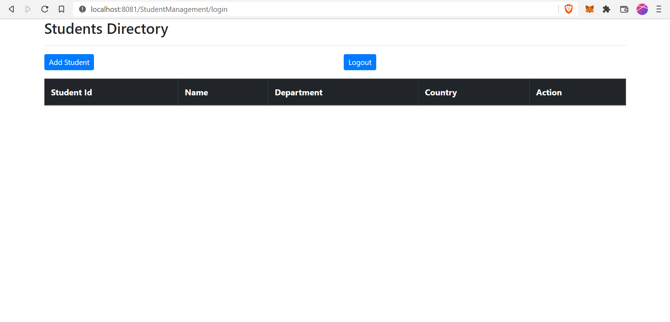

Add Student Page

Student List page

*You can see one student has been added.*

Normal user can not delete/update student data

Login with admin credentials

Update student details

*Only admin can update the details. Student name is being updated.*

Student list page

*Now we can see Student name has been updated from “Raju” to “Raju Kumar” .*

**

Delete Student

*Only admin can delete the student data. Before deleting the data, application ask admin to confirm if they really want to delete it.*

**

Student list page

*Student data has been deleted successfully.*

g